

THE BRUCE BILLITIN

Get on your dancing shoes, you sexy little swines! Or so said Alex Turner in his lyrical masterpiece “Dancing Shoes”. This week the theme is dance, with our own Bruce dance team letting their feet loose on the arts centre on Tuesday night, before we all can do a bit of dirty dancing at the Griffin-Bruce buttery night. Note: The Billitin does not take any responsibility for anyone trying to do a lift a la Patrick Swayze on Thursday.

**ISSUE 13: Monday 16th May – Sunday 22nd May**

*Doing it for Bill since 2014*

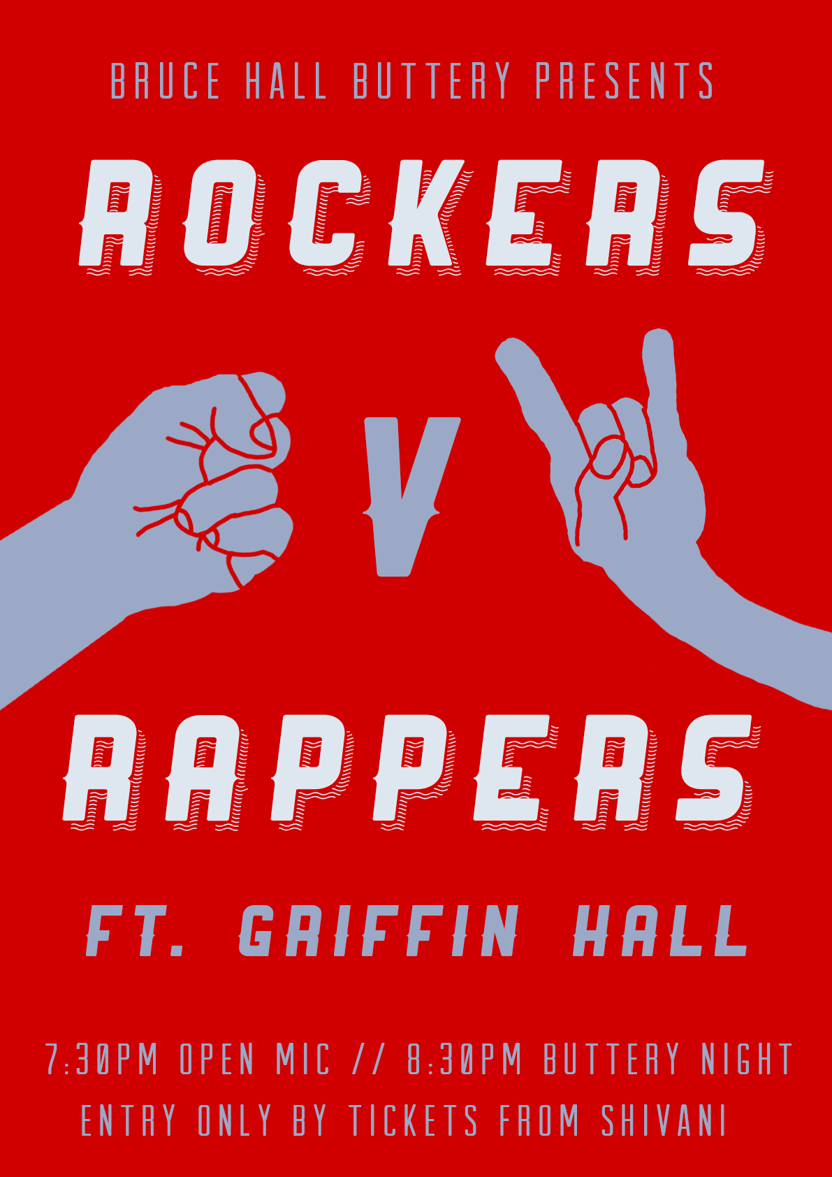

CANBERRA ANTIQUES & VINTAGE FAIR  
**13-15th May Canberra Southern Cross Club**

Feeling more hip than an arts student in coffee grounds? Your vintage lamp collection not quite up to scratch? Then head to this surefire hit of an event with ‘items to suit all budgets’. That includes you, Mr ‘Dominos is an appropriate date night location’.

CANBERRA SCAVENGER HUNT

**21st May Fountain outside Canberra Centre 1pm**

When the amazing race meets treasure hunt meets walking tour meets Canberra you have the Canberra Scavenger hunt! If you feel like you don’t really know Canberra, and want to explore it while performing witty and wacky challenges, check this out!

CANBERRA CITY BAND & CANBERRA YOUTH ORCHESTRA  
**1:30pm 22nd May High Court of Australia**

Bringing together two of the ACT’s most powerful musical forces in our own most powerful court. This will be a great performance in a majestic setting, with a program focusing on works with a penchant for electricity and excitement. If you plan on being a poverty stricken musician in your later life, or you just have an interest in music, see this. Tickets can be booked at:  
https://www.eventbrite.com.au/e/canberra-city-band-canberra-youth-orchestra-tickets-24724336155

PUBLIC LECTURE BY UN PRIVACY RAPPORTEUR JOE CANNATACI

**17th May 6-7pm Finkel Lecture Theatre**

The right to privacy is a contentious issue on the global, legal and political stage, and one which presents a significant challenge in our day and age. Listen to this UN-appointed expert in the field as he tells us his views on privacy and data protection, in what is sure to be a thought provoking presentation.

FACTORY: Fix & Make event

**21st May 10-3pm Hotel Hotel Canberra, New Acton**

A fully operational factory production line is going to be set up in Hotel Hotel, one which makes textiles to produce a pencil case, and you are invited to join in. You can hop in at any point in the production line and help out in cutting, sewing, labelling, quality control, pressing or packaging. Join in to get a unique perspective into what goes into making each and every item you wear, and get a new appreciation of the work put into your own materialistic items (deep huh?).

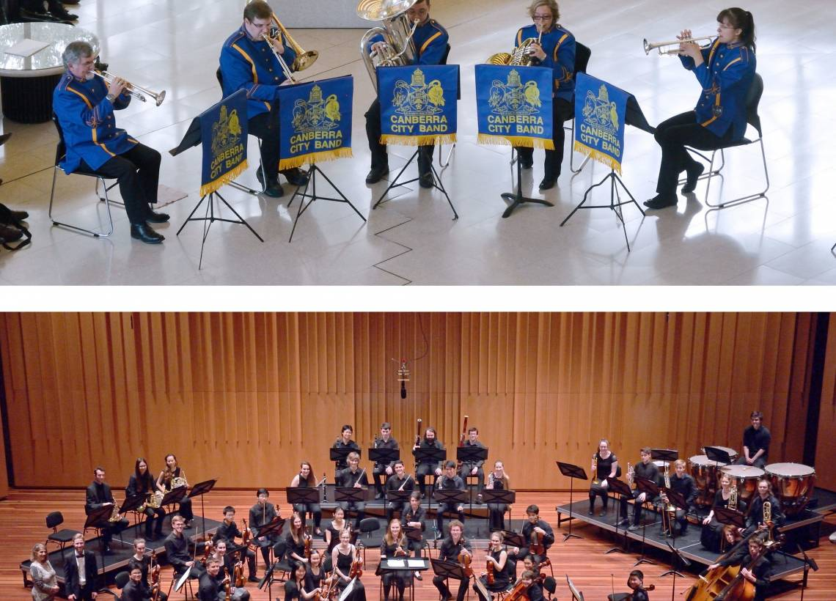

*You’re only given a little spark of madness. You mustn’t lose it* - Robin Billiams



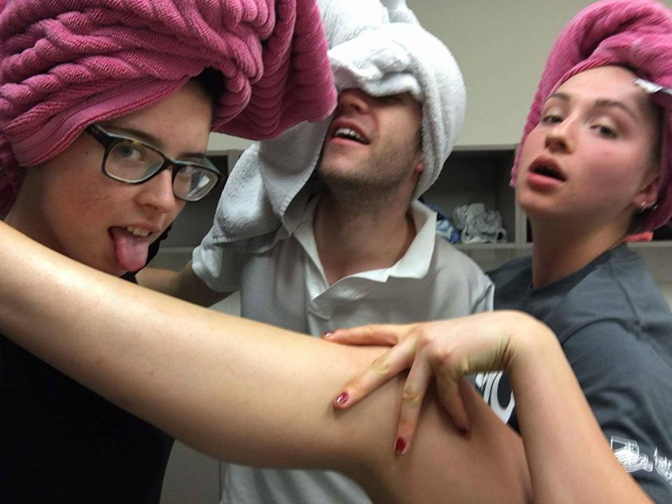

SO YOU THINK YOU CAN

DANCE WITH KELSEY

WALSH

When I was part of the circus, I was told on a dark and stormy night by my mentor, Beyonce Knowles, that dancing is all about feeling. Feeling uncomfortable and letting others know it, whether it be through facial expressions or a pose which causes others to wince in shared agony. See, the art of Dance is not in grace or elegance, as some say, but is in conveying your emotions, showing those around you that the music is in you. Literally in you, and that you are fighting to get rid of it. However, I know that those among you with two left feet (so all of Bruce’s buttery night dancers) might need a few choice moves to get you started, so here is my selection.

* **The Twerk:** You’ve got to werk it to twerk it. Show up the dancefloor in the most sophisticated way possible with this hard to miss move!
* **Moonwalk:** Ahhh the moonwalk. From the very first time I saw Michael Jackson glide across a stage I knew that I was destined to join him. A move which would make Louis Armstrong himself say ‘one small step for a man, one giant leap for dance’.
* **Jazz hands:** How can we ever forget the beauty of the jazz hands? That entrancing shake, the glittery promise, an intangible question of what it all means. Jazz hands promise so much, and so earn their place in my dance move pantheon.
* **Shuffle:** If every day you find yourself shuffling slowly to the dining hall, why not transfer that skill to the dancefloor? This move screams ‘I’m panicking about everything’ so why not use it this week before exams.
* **Dirty Dancing lift**: Ahhhhh if Swayze lifted me up my dancing would definitely become dirty. The final move in my list is also my favourite, and one that you may be able to convince me to do at a future buttery night, with Tarlinga’s help…

BRUCE HALL: An interactive Guide

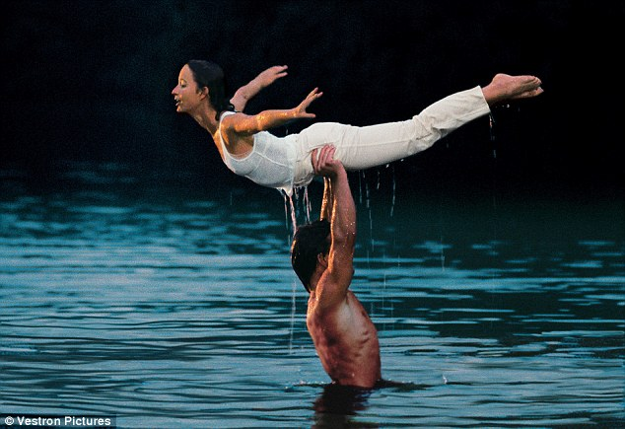

INTERHALL DANCE NIGHT

**17th May 7pm ANU Arts Centre**

Here it is. The event I’m sure you’ve all been waiting for. Tickets are sold out, but that doesn’t mean you can’t support our dancers. They’ve put a lot of practise into it, so make sure that you show them it’s been worth it!

ROCKERS VS RAPPERS: Griffin & Bruce buttery night  
**7:30pm Buttery 19th May**

Let your hair loose, your tacky trackies n gold chains out, because it’s time to bring out that inner rock god or truth spitting rapper. This is a mixer, and hence you may actually have to acknowledge Griffin’s presence, but fear not, we’ve heard they ain’t too bad, and that we’re going to have some awesome performances from 7:30 to make up for the invasion of our buttery!

BRUCE FORUM

**22ND May 8pm JCR**

This will be our once in a semester forum to discuss Bruce. The first half is a food forum in which you can talk about anything pertaining to Bruce food, while the second half is a general discussion about ANYTHING you want to talk about. If you would like to talk about anything in particular at the forum please send a message through to Vienna, and then everyone can discuss it!  
This will be a space for people to be transparent about any criticisms they have of Bruce, and suggest possible improvements, so we would like as many people there as possible to have their say!

TRIVIA

1. Who wrote the popular song ‘Do you remember’? 7. Who scored the most goals in the English premier league   
2. What dessert was supposedly named after a famous dancer? 2015/16 season?

3. What country has only one television channel? 8. What animal is the symbol of the US Democratic Party?

4. What year was Wikipedia first created? 9. What was the first play Shakespeare wrote?

5. What country has the longest coastline in the world? 10. Who was the first human to travel into space?

6. Which element has the symbol Au on the periodic table?



TRIVIA

1. Jarryd James, 2. The Pavlova, 3. Liechtenstein, 4. 2001, 5. Canada,, 6. Gold, 7. Harry Kane, 8. The Donkey, 9. Henry VI, 10. Yuri Gagarin.